# Instructions to set up a Gantt calendar view as seen below

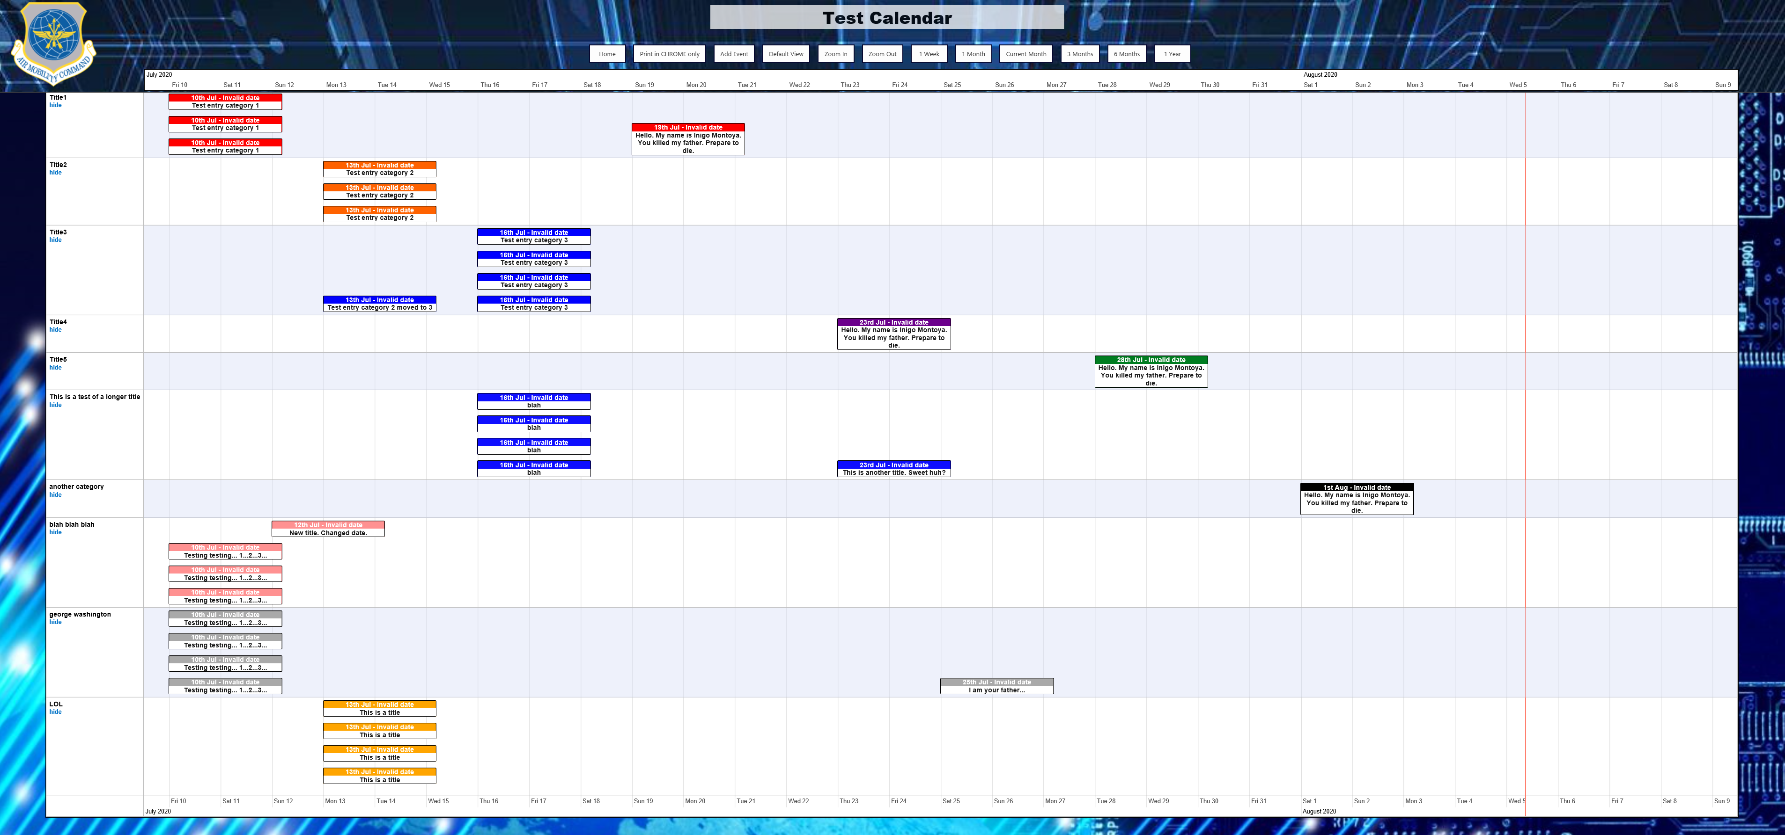

This calendar is to display calendar events as a single day event. The left side of the event’s box will align with the Start Date of the event.

1. Create custom lists for the calendar and categories. Note: List names can be anything you want, but column names must be exactly as below!
   1. Create a custom list to hold the categories for the calendar events with the following columns:

Column Name Column Type Default Value

* + 1. Title Single line text <blank> Standard SharePoint title field
    2. Sort Order Number <blank> Changes display order on calendar
    3. Gantt Color Single line text <blank> Changes background color of header
    4. Text Color Choice (Black or White) Black

Note: The choices for the text color can actually be any text value as seen here: <https://www.w3schools.com/cssref/css_colors.asp>

* 1. Create a custom list to hold calendar data (Note: Not a Calendar List) with the following columns:

Column Name Column Type Default Value

* + 1. Title (mandatory) Single line text <blank> Standard SharePoint title field
    2. Start Date (mandatory) Date <blank> Start date of calendar item
    3. End Date (mandatory) Calculated – Date Formula = ‘=[Start Date]’
    4. Category (mandatory) Lookup Title field of categories list above

1. Upload the contents of the Scripts folder in this zip file to your Site Assets folder. Note: Example images are included if you would like to use those for you header and page backgrounds as seen in the image above.
2. Update the included SingleDayCalendarGantt.txt file.
   1. Open the text file with a text editor. I suggest Notepad versus Word to avoid any extra formatting caused by Word.
   2. At the top of the file where it says ‘Edit this section’, update the 5 URLs to point to the files that you uploaded to your Site Assets.
   3. Update the two variables with the names of the Calendar list and Categories list that you created previously. You can also modify where the Home button on the calendar redirects to, the default view, the logo, and the backgrounds for both the header and the main body of the page.
   4. If desired update the CSS for the .vis-item width and margin to adjust the size of the items that are displayed on the calendar.
   5. Save the SingleDayCalendarGantt.txt file and upload it to the Site Assets as well.
3. Create a page to display the Gantt calendar.
   1. From your Site Contents click on the Site Pages folder.
   2. From the menu bar click ‘Files’, then click the dropdown arrow for ‘New Document’ and then select ‘Web Part Page’.
   3. Give the page a Name.
   4. For Page Layout leave it as the default ‘Header, Footer, 3 Columns’.
   5. Click ‘Create’.
   6. Once created click on the Name of the page you created to go to the page.
4. Edit the page to display the calendar.
   1. At the top right of the page click the gear and click ‘Edit Page’.
   2. In the Header section click ‘Add a Web Part’.
   3. Under Categories choose ‘Media and Content’.
   4. Click on ‘Content Editor’ and then click ‘Add’.

Your page should now look something like this:

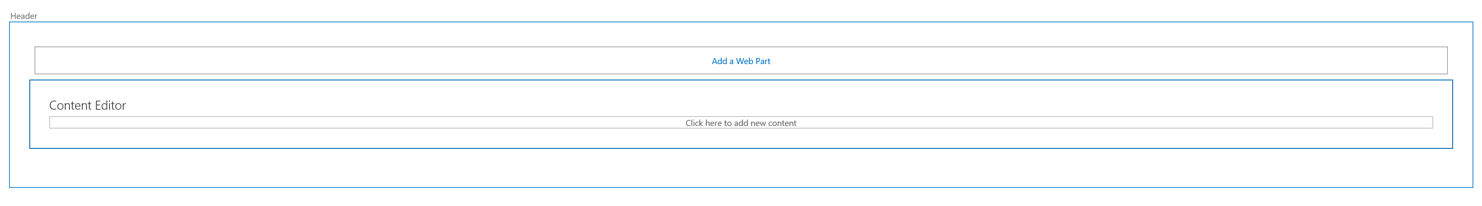

* 1. Edit the Content Editor web part. In the Content Link enter the URL to the SingleDayCalendarGantt.txt file that you uploaded to your Site Assets (i.e. https://eim2.amc.af.mil/Subsite_Name/SiteAssets/ SingleDayCalendarGantt.txt). Click OK.
  2. This should load the calendar with some visual glitches.
  3. To fix this issue remove everything after .aspx on the address bar and hit enter. The page should refresh and look correct now.